Webexercises to Bookdown

- Open R-Studio, set working directory to folder the bookdown files will be stored in
- In R create a new project
New project… ->
New Directory ->
Book project using bookdown ->
Set directory path and type in a subdirectory ->
Create Project
Make sure the output is set to gitbook

This creates all files for a generic bookdown project. Bookdown projects need to be made in R projects for separate webpages to work properly.

- Run code:
library(webexercises)
add_to_bookdown(output_format="gitbook")
This creates all files necessary for a template bookdown file that can use functions from webexercises.

- Replace the yaml in the index.Rmd with:
---
title: "Test Lab"
site: bookdown::bookdown_site
output: bookdown::gitbook
documentclass: book
bibliography: [book.bib, packages.bib]
link-citations: yes
---

- Edit the index.Rmd and “01-section1.Rmd”, “02-section2.Rmd” etc. files for each subsequent section in the lab.

- To add some webexercises examples from the webexercsies template…

Select the 07-references.Rmd file and click ‘Rename’


And rename as 08-references.Rmd

File > New File > R Markdown…
From Template
Web Exercises
File > Save…
07-section_webexercises_template.Rmd

Replace the first block of code with # Web Exercises

- Build tab -> Build Book

Publishing to Github Pages
** 14/06 Check if this can be set up so that multiple Github pages (URLs) are created from different folders in the same repository, e.g. can “S2S Statistical MM&C 1” folder be the repository with various subfolders (Labs/Lectures/etc.) containing Rprojects that create different bookdown docs that are then published to GitHub pages???**

Download/open Github desktop linked to account:
- Glasgow-Stats-L1-L2
- P/w H2%trbC827Jw (Changed password 21/11/2022)
- stats-level1@glasgow.ac.uk

In Github desktop…
- Create new repository (where files are to be stored remotely and locally) File > New repository…
- Publish repository (uncheck keep this code private)
- Show files in repository explorer
- Copy ALL bookdown files to folder
- Add summary e.g. “Added files”
- Commit to main
- Push origin
In Gitub on web… https://github.com/
- Find repository
- Enter “docs” folder
- Add file (menu) > Create new file
- (Name your file) nojekyll
- “Commit new file” (bottom page button)
- “Settings” (top menus – far right)
- Pages (Side menus – last in “Code and automation”)
- Branch – choose “main” (from dropdown)
- Folder – choose “docs” (from dropdown)
- Save
- Under Branch it will say “Your GitHub Pages site is currently being built from the /docs folder in the main branch.“ DO NOTHING.
- WAIT (until “Your site is live at…” appears at top of page)
- [Perhaps after a manual page refresh] “Your site is live at https://glasgow-stats-l1-l2.github.io/... /” appears
- Click on the “Visit site” link

Cloning/updating the source files from/to Github

To link to URL pages (repository) published (by someone else) on
https://glasgow-stats-l1-l2.github.io/

IF logged into Glasgow-Stats-L1-L2 on Github desktop
- Add (Drop down next to Filter – upper left)
- Clone repository…
- Select repository on Github web to duplicate locally
- Choose local path where you want to duplicate the repository
- Clone

IF URL pages have been published BY YOU, to update them..
Make changes locally via Github Desktop
- “Show in Explorer”
  - Open .Rproj file and make edits then ‘Build book”
  - OR copy over files edited/built elsewhere locally ??
In Github Desktop
- Updated files will be listed (with changes highlighted)
- Type in a “Summary”, e.g. “Updated Part 2 MB”
- “Commit to main” (bottom left)
- “Push origin”

URL will have updated but may need “hard refresh” to show, i.e.
- Ctrl-Shift-R (hard refresh)

Webexercises Useful Hints

- Don’t name sections using {#sec:section_name}, instead just use {#section_name}

- To put a box around a section of text, wrap text in:
::: {.webex-box}

:::

- To make code chunks differentiable from normal text in these boxes, change the background-color to be the following in the webex.css file
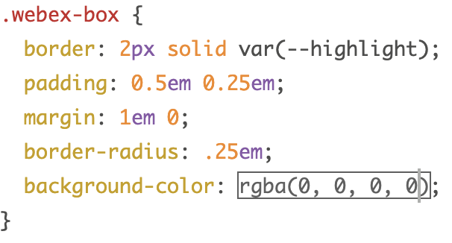

Create Organisatoin on Github.com
Add repositories to that Organisation on Github.com
Individually Clone these repositiores on Github desktop, folder
- Code > HTTPS > Copy
- Github Desktop > File > Clone Repository > Select URL Tab>Paste
  - specifying local path
  - Clone
NB. Don’t give others access to the Onedrive folder that contains the cloned repos

